Evolution Assignment 2: Genetic Drift

This is your second assignment for Topic 9, worth 2.5 % of your course. Ensure that you complete both: Part 1 (worth 1.5 %) and Part 2 (worth 1%)

Part 1: Questions regarding genetic drift
Use the graphs below to answer questions 1-8, (short answer, 1-2 sentences or bullet points)

The graphs below show simulations of two scenarios regarding one gene (alleles A/a):

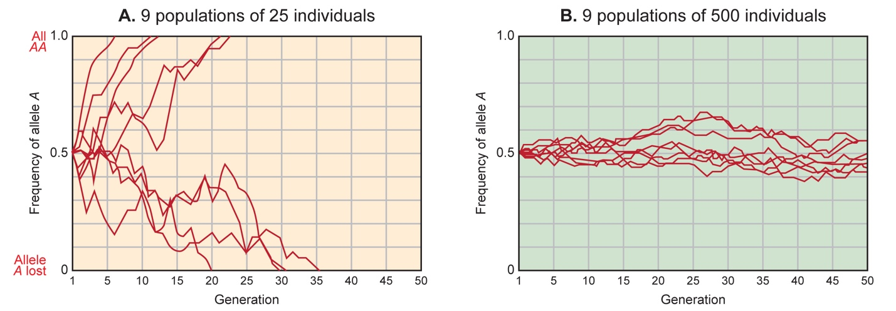
Source of graphs: https://evolution.berkeley.edu/evolibrary/home.php

- Explain what is shown on the x- and y-axes. 1 pt.
- X-axis shows the generations of sampled population of allele A for 25 individuals in graph A and of 500 individuals in graph B.
- Y-axis shows the change in frequency of allele A of 25 individuals in graph A and of 500 individuals in graph B.
- Choose two lines on graph a, one that goes to the top of the graph and one that goes to the bottom. For each line, explain what the line represents and how it changes over time. Also, explain what it means when a line goes to the top of the graph versus what it means when a line goes to the bottom of the graph. 3 pts.
- When a line goes to the top of a graph, the allele A is approaching frequency of 1 (100%) which is said to be fixed.
- When a line goes to the bottom of the graph, allele A is approaching frequency of 0 (0%) which is said to be lost.
- In graph A, the frequency of change of the lines is rapid because fixation and lost is achieved rapidly with a smaller sampled population.
- In graph B, the frequency of change in line is minimal because, fixation and lost cannot be achieved with a large sampled population.
- An allele is said to be fixed when the genetic drift comes to a halt, meaning frequency cannot change unless a new gene is introduced through mutation.

- Explain the difference between the simulations that generated graphs A and B. 1 pt.

Graph A has smaller sampled population than graph B. The frequency of genetic drift is higher with a smaller population than with a larger population.
- Why do y-values fluctuate in each graph? 1 pt.
Y values are fluctuating because they represent the variations of allele frequency due to genetic drift.
- In graph A, how many of the trials resulted in a frequency of A = 1.0 and how many resulted in a frequency of a = 1.0? Why might this occur? 2 pts
- Three trials led to frequency of A=1.0 and two trials led to frequency of a=1.0.
- This occurred because in a small sampled population, the frequency of these alleles fluctuates greatly, some will become fixed within the population and some will disappear due to genetic drift events.
6) The populations represented by graph A and graph B demonstrate very different behavior. What concept regarding genetic drift does this illustrate? 2 pts
- Sampled population in graph A (25 individuals) is smaller than sampled population in graph B (500 individuals).
- This shows that the frequency of genetic drift is higher with a smaller population than with a larger population.
- This means that, genetic drift is inversely proportional to the size of population, the smaller the size, the greater the frequency of genetic drift and the higher the population, the smaller the frequency of genetic drift.
7) If one allele were under selection in graph B (contributed negatively to fitness), how would this graph differ? 2 pts
- For a larger sample, the allele frequency of each gene is relatively stable because the genes are not affecting fitness.
- If one allele were under natural selection, it would pose pressure against the allele frequency. If an allele contributed negatively to fitness, its frequency will tend to fluctuate from one generation to the next.
8) How would each of these graphs differ if starting allele frequencies in the simulations were not 50/50—for example, if the populations began with 30% A allele and 70% a allele? Would drift occur? 3 pts Test your hypothesis in Part 2.
- Yes genetic drift will occur but at a relatively slow frequency.
- Genetic drift will be felt more with the 30% allele than with the 70% allele.
- C. Genetic drift is more frequent with smaller population than with larger population.
- At the end, the 70% allele will be dominating and the species at threat will be the 30% allele A.
Part 1_______/ 15 = ________/1.5 %
Part 2: Simulation Exercise
Generate one simulation for allele A= 30 % in a small (25 individuals) and large (500 individuals) population. Compare and contrast your results, summarize (use “proportion of R allele” and allele proportion graph), provide a figure (e.g. screenshot of the data page) for each simulation. Did you observe genetic drift? If so, in which population and why? Briefly comment on the implications of your results regarding a threatened species like the Southern Mountain Caribou or the Polar Bear. Write a concise paragraph (about 100 words, provide a word count)

Use the following website (in addition link provided in this folder)
http://virtualbiologylab.org/ModelsHTML5/PopGenFishbowl/PopGenFishbowl.html
Read the background information, go through the tutorial and run two simulations:

Simulation A: A population with 25 individuals, carrying capacity of 25, ‘R’ allele = 0.3 (that corresponds to 30 % A), see screenshot below, run for a minimum of 50 generations, take a screenshot of your data

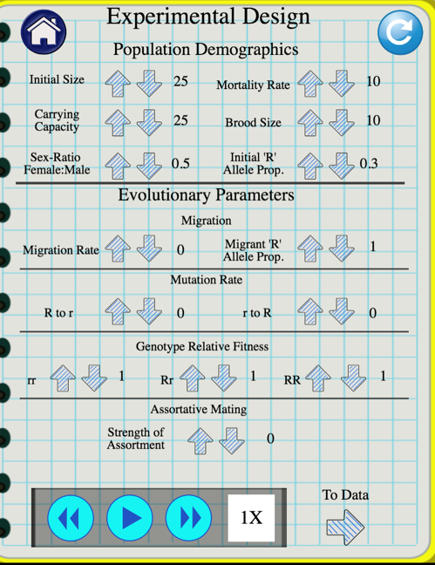
(Fig. 1)

Simulation B: A population with 500 individuals, carrying capacity of 500, ‘R’ allele = 0.3 (that corresponds to 30 % A), see figure below, run for a minimum of 50 generations, take a screenshot of your data

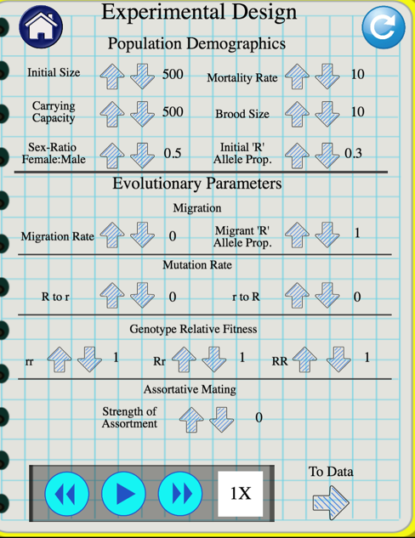
(Fig. 2)
Result
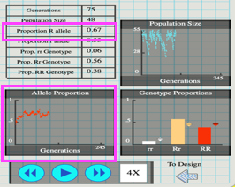

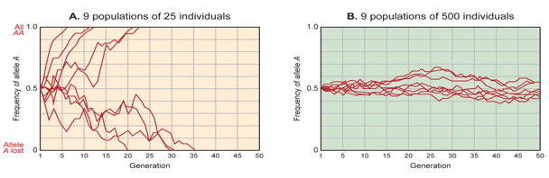
Discussion.
Sampled population in the first simulation consists of 25 individuals which is smaller than sampled population in simulation B of 500 individuals. The frequency of genetic drift is higher with a smaller population than with a larger population. Genetic drift is higher in simulation A than with simulation B. On the other hand, Genetic drift will be felt more with the 30% R allele than with the 70% allele. The probability that an allele will eventually become fixed in the population depends on its frequency in the population at that time. Fixation occur much more rapidly with a smaller population. Therefore, the species that will face more threat are the 30% R allele from the sampled population of 25 individuals.

